UIAA Mountaineering Commission

Training Standards

Ski touring and winter walking Seminar

Slovenia 2013, 6th – 8th of March

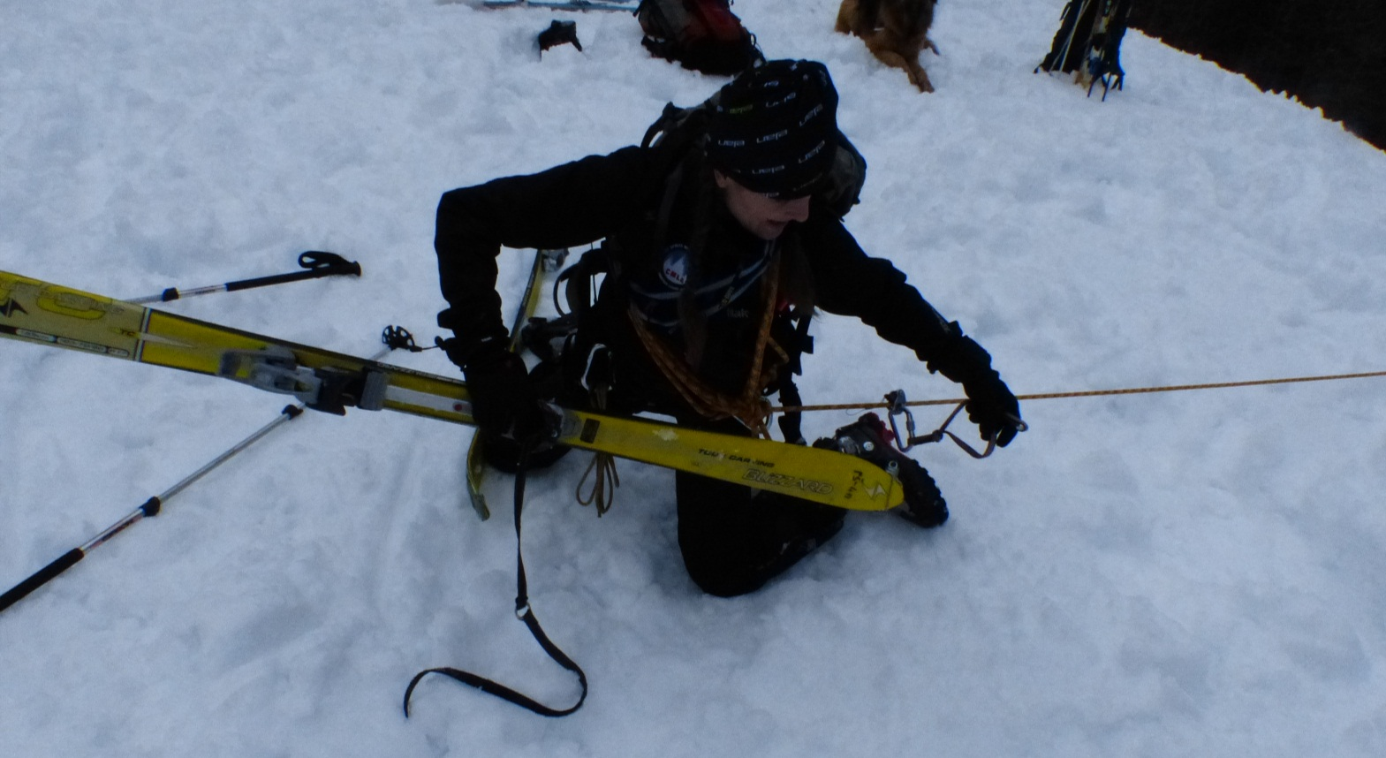
Ski touring and winter walking Seminar: Slovenia 2013

6/3/2013 (category 3 avalanche risk)
Modern avalanche transceivers and other safety equipment (Robert Ciglar)
- Uses and limitations of digital and analogue transceivers
- Introduction to new Vector transceiver with integrated GPS
- Simple transceivers for clients
- Importance of simple functionality in crisis situations where every second counts
- Importance of finding casualty airway
- Back-up transmitters for rescuers (for secondary avalanche; separation from transceiver
- Uses and limitations of iProbe (digital probe)
- Uses and limitations of ABS systems + avalung
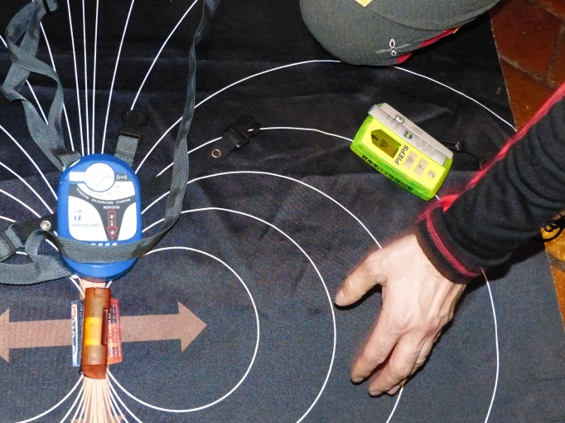
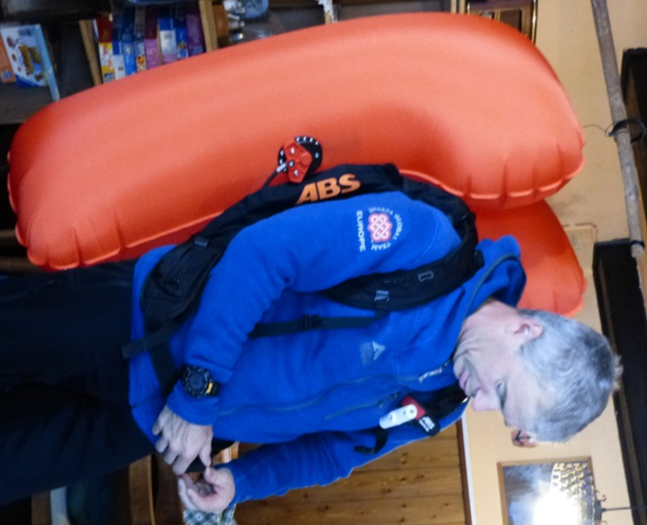

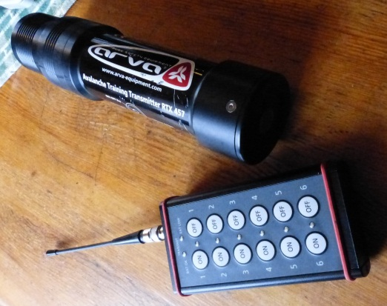

Teaching resources for transceivers (by Sergey Videnin)
- Introduction to Avra low powered transmitter to simulate 20 metre range on a floor chart showing flux lines
- Practical exercise in the field using Arva training transmitter system for multiple burials.
- Probing and digging
Snowshoeing (Klara Havlichkova)
- A “reserve” session, not used apart from brief introduction to choice and fitting
Dynafit (Tomaž Komac)
  - Demonstration of racing and touring kit:
  - integrated system of ski, binding, boot
  - Correct fitting of binding for safe release
  - Use of heel piece for various slope angles
  - When to lock the toe binding and when not to

7/3/2013 (category 4 avalanche risk)
Ski touring, Elan Skies (by Davo Karnicar);
- Demonstration and testing of Élan ski range
- Route choice
- Teaching basic skills,
- setting tracks
Avalanche risk testing (Klemen Volontar)
- which method, how much is taught, and what?
  - Correct method and categories for hardness test
  - Marking hardness profile on snow face
  - Compression test
Navigation – GPS (Klemen Volontar and Matjaž Šerkezi)
- Uses and limitations of modern GPS and mobile phones
  - Dangers of over-reliance on GPS
  - Internal vs. external antenna
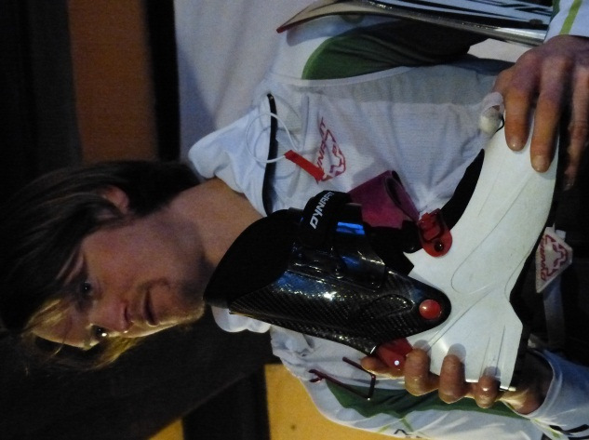
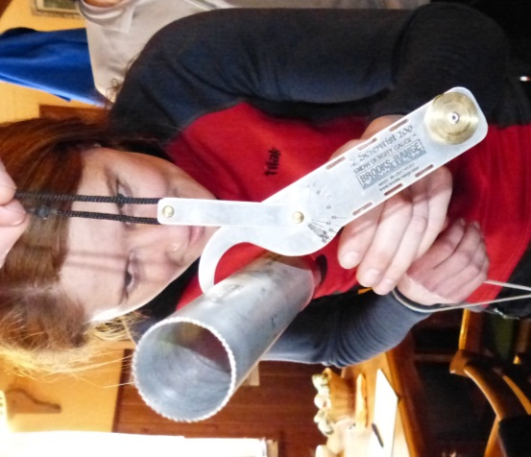
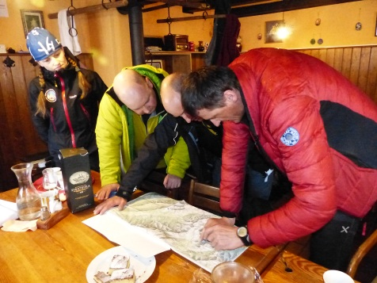
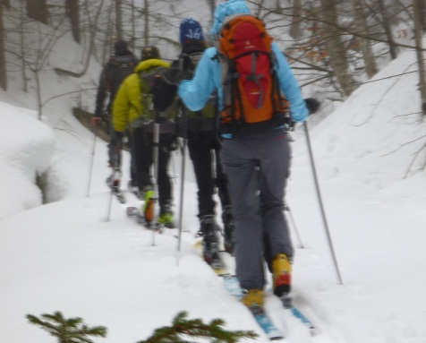
  - Educational opportunities for understanding maps
Digital mapping
  - Vector and bitmap versions
  - Garmin maps and custom maps
  - Other mapping software
  - Uses and limitations of online routes
Navigation – dead reckoning (Steve Long)
- Estimating distance travelled
  - modifications for snow conditions
  - Visualisation (and its limitations)
  - Timing
  - Pacing on flat and uphill (walking and skiing)
Movie First skiing from Everest (Davo Karničar)
8/3/2013 (category 4 avalanche risk)
Crevasse rescue
- Further testing of “Sergey” snow shovel anchor
- Buried skis “deadman” anchor
- “Picket” ski anchor
- Hoist systems
  - Basic 3:1 Z-hoist
  - Improved Z-hoists
  - New equipment for hoisting
    - Micro-traxion
    - RescYou (see review on UKclimbing)
    - Rope “snake sling”
- Emergency procedures for crevasse falls on skis
  - Stopping the fall
  - Setting up anchors
  - Setting up hoist system
Leading groups on steeper terrain.
- Uphill, downhill. (Christian Frischknecht)
  - “Wheel rung” turns
  - Graceful kick turns
  - Helping less confident skiers turn
    - Teaching kick turns
    - Platform with downhill kick turn
    - Standing below using poles to give security
  - Side stepping uphill with free heels
  - Telemark turns with skins
